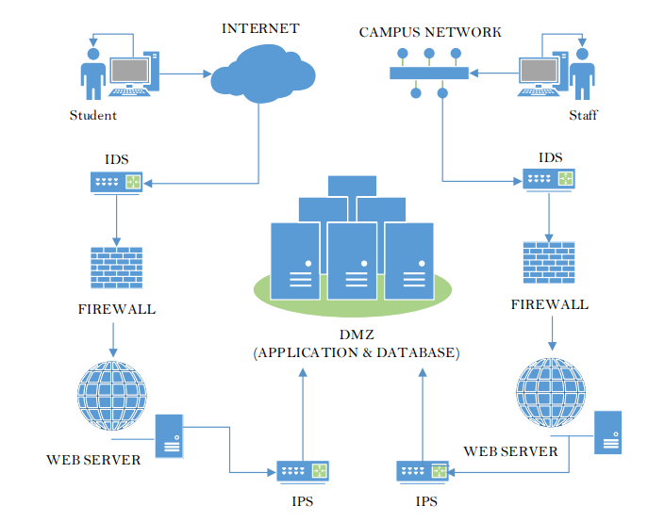

**Question 1**

1. Asset identification
2. Threat identification
3. Potential incident and consequences (L,M,H)
4. Potential vulnerabilities and recommendation
5. Risk treatment (data losses)
6. Risk treatment (unauthorized access)
7. Nonconformity Status

**Question 2**

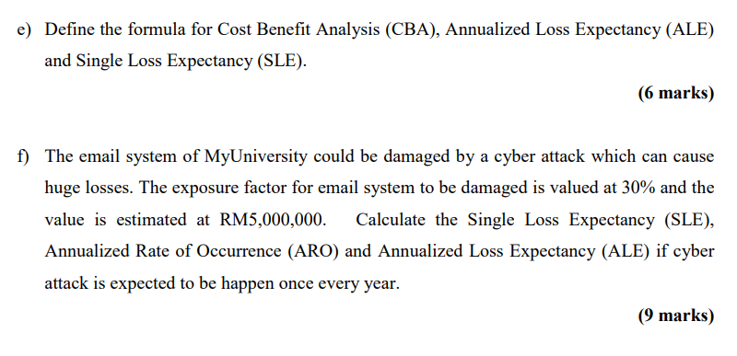

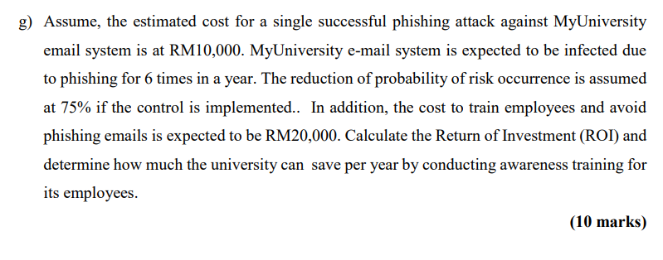

Terms:

Asset Value, Exposure Factor, SLE, ARQ, ALE, Cost of Control, Reduction in Risk, ROI

**Question 3**

ISMS

ISO/IEC 27002

ISO 19011 and ISO 3100

ISO/IEC 17021 and ISO/IEC 27006

Auditor Role